**COMMUNITY DEVELOPMENT PLAN**

**A DEVELOPMENT PLAN GUIDE FOR RURAL & MARITIME COMMUNITIES**



***Ministry of Rural and Maritime Development & Disaster Management***

**PART A**

**OVERVIEW**

The Community Development Plan (CDP) has been designed to complement the bottom-up approach of identifying and prioritizing rural community development projects.

Its purpose is to encourage the active participation of community members and their respective development committees in identifying and mapping their development needs. It seeks to capture the development priorities and plans of these communities in the short-term (6 months to 3yrs), medium-term (3yrs – 5yrs), and long-term (5yrs – 10yrs).

The CDP comprehends all relevant and cross-cutting national policies, strategies, and goals relating to rural development, climate change, and disaster resilience and readiness. This includes the Fiji Government’s 5 – 20yr NDP, the UN Sustainable Development Goals 2030, and the Ministry’s 10-year Strategic Development Plan.

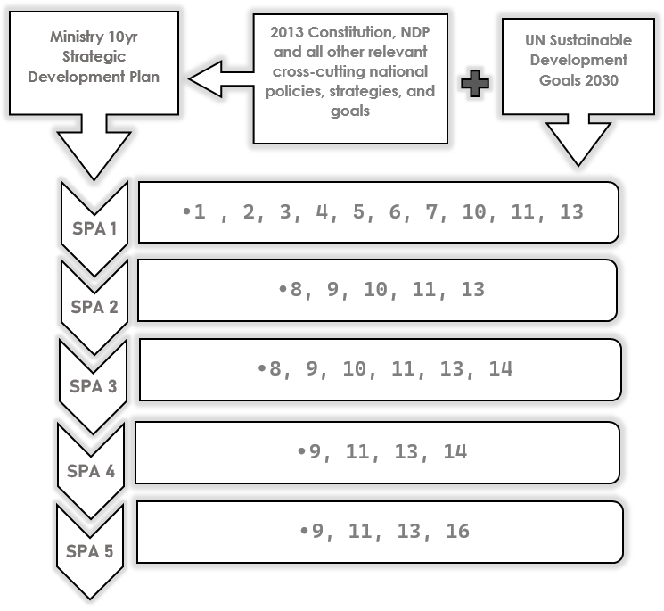

CDP Focus Area

The CDP focus areas are directly representative of the five (5) Strategic Priority Areas of the Ministry’s 10-year Strategic Development Plan. The focus areas as detailed below:

|  |  |  |  |
| --- | --- | --- | --- |
| **STRATEGIC PRIORITY AREA (SPA)** | | **GOAL** | **FOCUS AREAS** |
| **1** | Ensuring Sustainable Living Standards & Resilient Communities | Rural and Maritime communities have access to essential services such as clean water and sanitation, adequate housing and waste management, health, education, and nutritional security | * Water * Sanitation * Housing * Health * Education * Waste Management |
| **2** | Improving Connectivity & Accessibility | Investment toward resilient infrastructure and services that improve the connectivity of rural and maritime communities | * Telecommunication * Digital Connectivity * Rural Roads * Shipping Services * Flights Services * Ports * Jetty’s Services |
| **3** | Sustainable Economic Growth & Resilience | Rural and maritime communities realize their social-economic and livelihood goals through the sustainable use of their natural resources. | * Income-generating initiatives * Community approach * Cooperative setup * Agriculture value-adding * Forestry value-adding * Fisheries business ventures |
| **4** | Effective Coordination of Disaster Operations & Disaster Risk Reduction | Building Resilience of communities to all hazards | * Evacuation Centres * Community Disaster Management Plan * Disaster Risk Reduction Projects (Adaptation/Mitigation) * Risk Informed Development Projects (RID) |
| **5** | Community Effectiveness & Good Governance | A skilled and agile organization delivering efficient and effective services to rural communities through enabling and empowering line ministries and partners | * Leadership * Networking * Establishment of Development Committees * Women Empowerment * Youth Empowerment * Training and Awareness |

**Process Map**

**PART B**

1. **Vision**

A Vision statement should be:

* Understood and shared by members of the community.
* Broad enough to include a diverse variety of local perspectives.
* Inspiring and uplifting to everyone involved in the community.
* Easy to communicate - for example, they are generally short enough to fit on a T-shirt.
* An inspirational statement that describes a community’s goal for the future and the impact it aims to make on the surrounding community and the country as a whole.

E.g.

“An empowered Namalata Village with sustainable economic livelihoods that are climate and disaster-resilient.”

**[Communities to develop and insert their own Vision Statements based on the guidance above]**

1. **Mission**

* Mission statements are more concrete, and they are more "action-oriented" than vision statements.
* While a vision statement should inspire people; the mission statement should inspire them to action.
* A one-sentence statement that is concise, outcome-oriented, and inclusive.

E.g.

“Promoting community development and resilience by connecting people, ideas, and resources”.

**[Communities to develop and insert their own Mission Statements based on the guidance above]**

1. **Situation Analysis of Community**

Summary of Community Intent for the next 5 – 10 years and current overview of the situation on the ground:

|  |  |  |
| --- | --- | --- |
| **Insert Summary:** | | |
| **#** | **Source** | **Count** |
| 1 | Total Number of Households |  |
| 2 | Total Population |  |
| 3 | Total Women Population |  |
| 4 | Total Children Population |  |
| 5 | Total Elderly Population (60yrs+) |  |
| 6 | Total Youth Population (18yrs – 35yrs) |  |
| 7 | Total Population of People with Disability (PWD) |  |
| 8 | Total Number of Households with Power Supply |  |
| 9 | Total Number of Households with Proper Water Supply |  |
| 10 | Total Number of Households with Proper Sanitation |  |
| 11 | Type of Power Supply (EFL Grid/ Diesel Generator/Solar System) |  |
| 12 | Type of Water Source (WAF/ Borehole/ Spring Source) |  |
| 13 | Number of Households without Water Supply |  |
| 14 | Number of Households without Power Supply |  |
| 15 | Number of Households without Proper Sanitation (Flush Toilet System) |  |
| 16 | Road Access – (Indicate Yes or No) |  |
| 17 | Public transportation availability - (Indicate Yes or No) |  |
| 18 | Type of public or communal transportation available – (Please List) |  |

*4.0 COMMUNITY DEVELOPMENT TEMPLATE*

|  |  |  |  |  |  |  |  |
| --- | --- | --- | --- | --- | --- | --- | --- |
|  | Priority Area 1: Sustainable Living Standards & Resilient Communities  *Focus: [ Water/ Sanitation/ Housing/ Health/ Education/Waste Management]* | | | | | | |
|  | Outcomes  *[What do we want to achieve?]* | Expected Output  *[What is expected to be achieved?]* | Activities  *[What do we need to do to achieve these?]* | Partner  Agency | Resources Needed  *[Financial/ Technical/ Contribution/ Personnel]* | Priority Ranking  *[1 – 5*  *Highest to Lowest]* | Timeline  *[Short-term: 6 months – 3 yrs.*  *Mid-term: 3 – 5 yrs.*  *Long-term: 5 -10 yrs.]* |
| *1.* | *Example – Water & Sanitation*  *Improved water supply to all households to ensure a safe and reliable water source and proper sanitation for all households within the village/community in the next 3yrs.* | * *Drop in the number of sicknesses previously caused by the HRW and HRS within the village/community* * *No. of water and sanitation projects in the village/community* | * *Establishment of a water committee* * *Meeting with key stakeholders* * *Scoping of water needs within the community to enable the prioritizing of needs per household.* * *Community fundraising for water/sanitation projects* * *Purchase of water tanks, pipes, and fittings based on scoping findings.* * *Installation of water projects and proper flush toilets facilities* | * *PA/DOs office* * *WAF* * *NGOs* | * *$8000* * *Technical Assistance to conduct scoping* * *Training for the newly established water committee* | *2* | *Short -term* |
| *2.* |  |  |  |  |  |  |  |
| *3.* |  |  |  |  |  |  |  |
| *4.* |  |  |  |  |  |  |  |
| *5.* |  |  |  |  |  |  |  |

|  |  |  |  |  |  |  |  |
| --- | --- | --- | --- | --- | --- | --- | --- |
|  | Priority Area 2: Improving Connectivity & Accessibility  *Focus: [ Telecommunication/ Digital Connectivity/ Rural Roads/ Shipping Services/ Flights Services/ Ports/Jetty’s Services]* | | | | | | |
|  | Outcomes  *[What do we want to achieve?]* | Expected Output  *[What is expected to be achieved?* | Activities  *[What do we need to do to achieve these?]* | Partner  Agency | Resources Needed  *[Financial/ Technical/ Contribution/ Personnel]* | Priority Ranking  *[1 – 5*  *Highest to Lowest]* | Timeline  *[Short-term: 6 months – 3 yrs.*  *Mid-term: 3 – 5 yrs.*  *Long-term: 5 -10 yrs.]* |
| *1.* |  |  |  |  |  |  |  |
| *2.* |  |  |  |  |  |  |  |
| *3.* |  |  |  |  |  |  |  |
| *4.* |  |  |  |  |  |  |  |
| *5.* |  |  |  |  |  |  |  |

|  |  |  |  |  |  |  |  |
| --- | --- | --- | --- | --- | --- | --- | --- |
|  | Priority Area 3: Sustainable Economic Growth & Resilience  *Focus: [ Income generating initiatives/ Community/Cooperative store/ Agriculture/Fisheries business ventures]* | | | | | | |
|  | Outcomes  *[What do we want to achieve?]* | Expected Output  *[What is expected to be achieved?* | Activities  *[What do we need to do to achieve these?]* | Partner  Agency | Resources Needed  *[Financial/ Technical/ Contribution/ Personnel]* | Priority Ranking  *[1 – 5*  *Highest to Lowest]* | Timeline  *[Short-term: 6 months – 3 yrs.*  *Mid-term: 3 – 5 yrs.*  *Long-term: 5 -10 yrs.]* |
| *1.* |  |  |  |  |  |  |  |
| *2.* |  |  |  |  |  |  |  |
| *3.* |  |  |  |  |  |  |  |
| *4.* |  |  |  |  |  |  |  |
| *5.* |  |  |  |  |  |  |  |

|  |  |  |  |  |  |  |  |
| --- | --- | --- | --- | --- | --- | --- | --- |
|  | Priority Area 4: Effective Coordination of Disaster Operations & Disaster Risk Reduction  *Focus: [ Evacuation Centres/ Community Disaster Management Plan/ Disaster Risk Reduction Projects (Adaptation/Mitigation)]* | | | | | | |
|  | Outcomes  *[What do we want to achieve?]* | Expected Output  *[What is expected to be achieved?* | Activities  *[What do we need to do to achieve these?]* | Partner  Agency | Resources Needed  *[Financial/ Technical/ Contribution/ Personnel]* | Priority Ranking  *[1 – 5*  *Highest to Lowest]* | Timeline  *[Short-term: 6 months – 3 yrs.*  *Mid-term: 3 – 5 yrs.*  *Long-term: 5 -10 yrs.]* |
| *1.* |  |  |  |  |  |  |  |
| *2.* |  |  |  |  |  |  |  |
| *3.* |  |  |  |  |  |  |  |
| *4.* |  |  |  |  |  |  |  |
| *5.* |  |  |  |  |  |  |  |

|  |  |  |  |  |  |  |  |
| --- | --- | --- | --- | --- | --- | --- | --- |
|  | Priority Area 5: Community Effectiveness & Good Governance  *Focus: [ Leadership/ Networking/ Establishment of Development Committees/ Women Empowerment/ Youth Empowerment/Training & Awareness]* | | | | | | |
|  | Outcomes  *[What do we want to achieve?]* | Expected Output  *[What is expected to be achieved?* | Activities  *[What do we need to do to achieve these?]* | Partner  Agency | Resources Needed  *[Financial/ Technical/ Contribution/ Personnel]* | Priority Ranking  *[1 – 5*  *Highest to Lowest]* | Timeline  *[Short-term: 6 months – 3 yrs.*  *Mid-term: 3 – 5 yrs.*  *Long-term: 5 -10 yrs.]* |
| *1.* |  |  |  |  |  |  |  |
| *2.* |  |  |  |  |  |  |  |
| *3.* |  |  |  |  |  |  |  |
| *4.* |  |  |  |  |  |  |  |
| *5.* |  |  |  |  |  |  |  |

***For clarification and guidance. Please contact:***

*Ministry of Rural and Maritime Development & Disaster Management*

*1 Knolly St, Suva.*

*P O BOX 2219, Government Buildings, Suva*

*Phone: 3313400*